NAME: Menahil Zaheer
CMS ID: 502881

Department of Computing

EE353: Computer Networks
Class: BSDS&AI

Lab 1: General Introduction to Wireshark and Networking
Time: 10:00 to 01:00 & 02:00 to 5:00
Date: 09-09-2025
Course Instructor’s: Hammad Saddiqui
Lab Engineer: Syed Muhammad Ali Musa
Lab 1: General introduction to Wireshark and Networking
Introduction
The basic purpose of this lab is to introduce you to Wireshark, a popular protocol analyzer. By the end of this lab you will be familiar to its environment and will know how to capture and interactively browse the traffic running on a computer network using it.

Objective
The objective of this lab is to understand basics of Wireshark and Networks.

Tools/Software Requirements
Wireshark

Important Instructions
- Read carefully before starting the lab.
- These exercises are to be done individually.
- You are supposed to provide the answers to the questions listed end of this document and upload this completed document to your course’s LMS site.

Questions:
Note: Write your answers here in red font. Paste the screenshot of the relevant output to substantiate your answers.

- Start packet capturing. 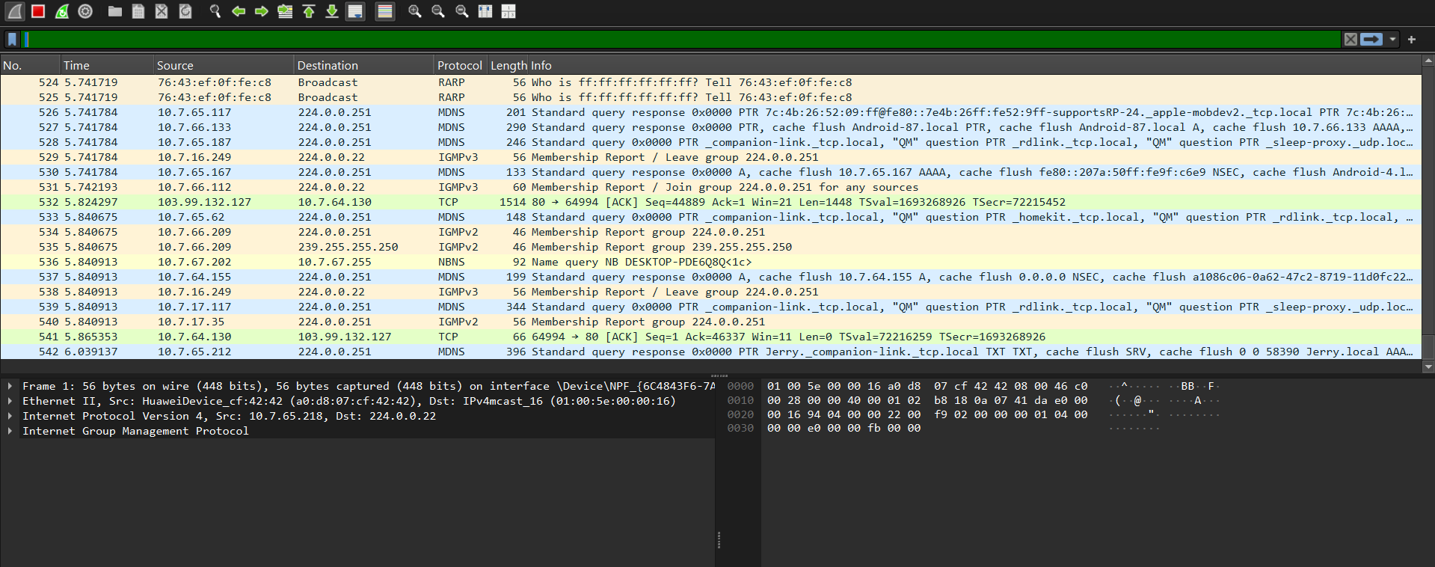
- List up to 10 different protocols that appear in the protocol column in the unfiltered packet-listing window and also explain them (only 2 to 3 Lines).
• Browser: Chrome, Edge, Firefox. Behind the scenes, a browser talks to web servers using protocols like HTTP/HTTPS and TLS, fetches data, and renders it into the web pages you see. It’s your window to the internet.
• TCP (Transmission Control Protocol): Think of this as the “careful delivery guy” of the internet. It makes sure data gets from one computer to another in the right order, without missing pieces. That’s why it’s used in web browsing, emails, and file transfers where accuracy matters.
• UDP (User Datagram Protocol): It is used where speed matters more than perfection. It just throws packets over the network without checking if they arrive. Because of that, it’s super fast which is why it’s used in gaming, streaming, and voice calls.
• TLS 1.3 (Transport Layer Security v1.3): This is what keeps your internet secure. It’s the modern version of the encryption protocol used in HTTPS. TLS is working behind the scenes to encrypt your data and keep it private.
• ARP (Address Resolution Protocol): On a local network, computers need to know each other’s “house addresses” (MAC addresses). ARP is like a phonebook that translates an IP address into the actual hardware address so devices can talk directly.
• RARP (Reverse ARP): An older protocol where a device requests an IP address based on its known MAC address. It was often used by diskless workstations to learn their IP during boot, but has been replaced by DHCP.
• mDNS (Multicast DNS): Lets devices on the same local network find each other without a DNS server. For example, your laptop can discover a smart TV or printer automatically.
• LLMNR (Link-Local Multicast Name Resolution): It lets Windows devices on a local subnet find each other when DNS isn’t available. Handy in small peer-to-peer setups.
• NBNS (NetBIOS Name Service): An older Windows protocol that turned names into IP addresses before DNS became standard.
• SSDP (Simple Service Discovery Protocol): This helps smart devices find each other on a home network. For example, a PlayStation discovering a media server or a smart speaker locating other devices. It’s part of the UPnP system.
• IGMPv2 (Internet Group Management Protocol v2): Useful for group activities on the internet. It manages multicast groups, meaning it lets a router know which devices want to receive a stream without sending it to everyone unnecessarily.

- Identify source and destination ip addresses and also try to find the ip address of your machine.
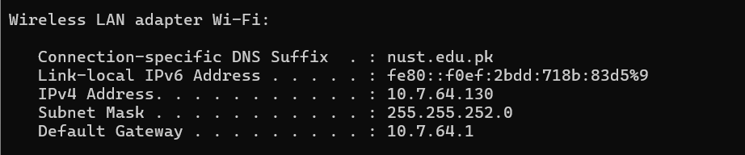

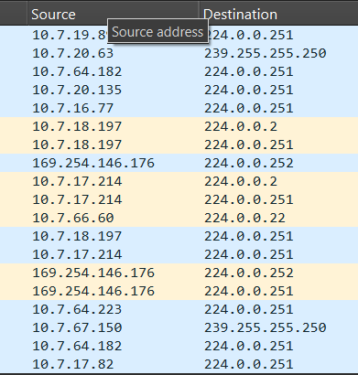

- Open statistics tab and explore the HTTP tab and also explore all its all options attach detailed screen shots.
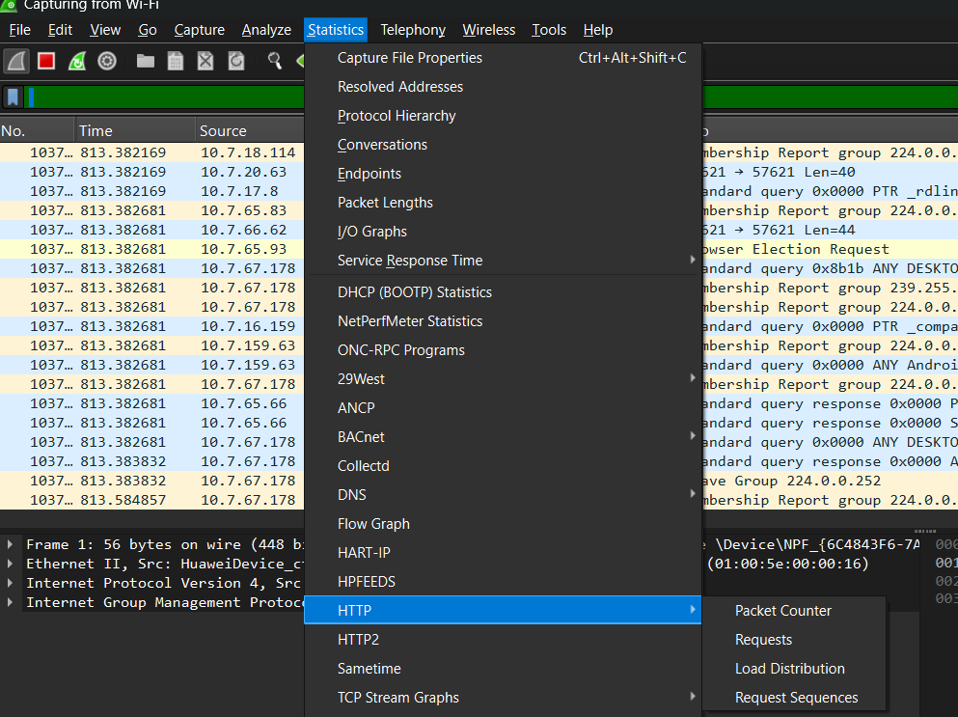

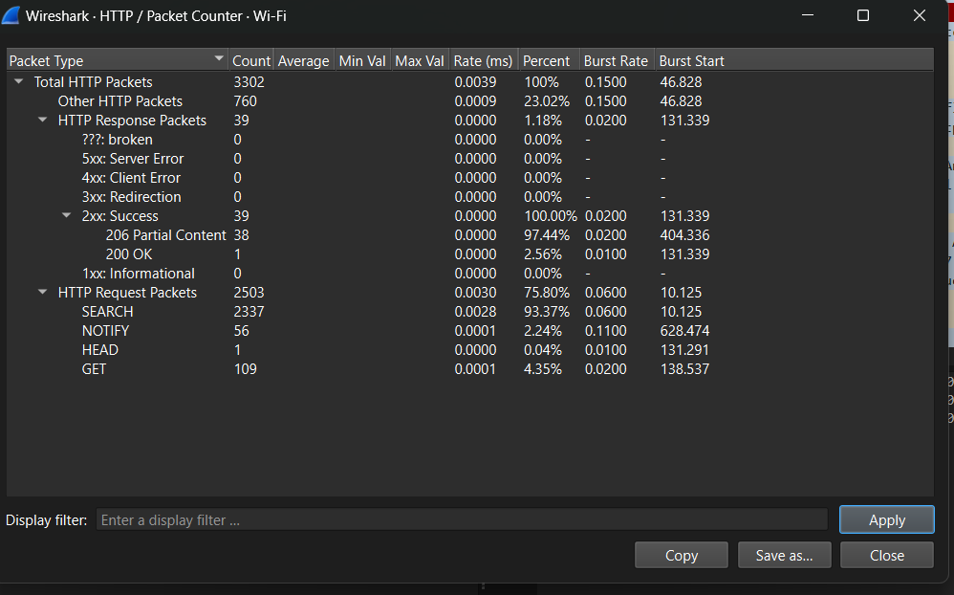
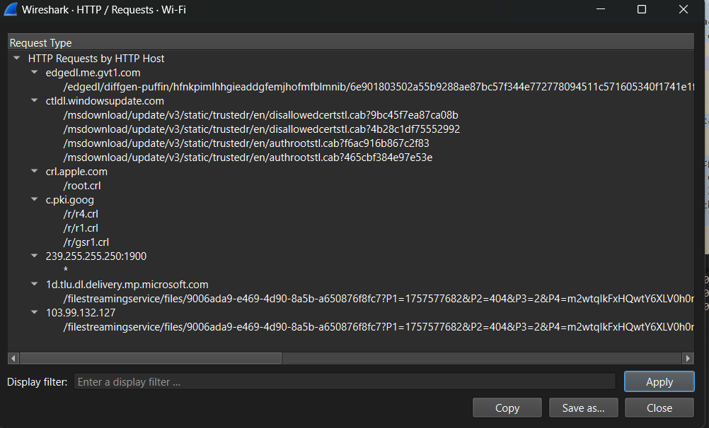

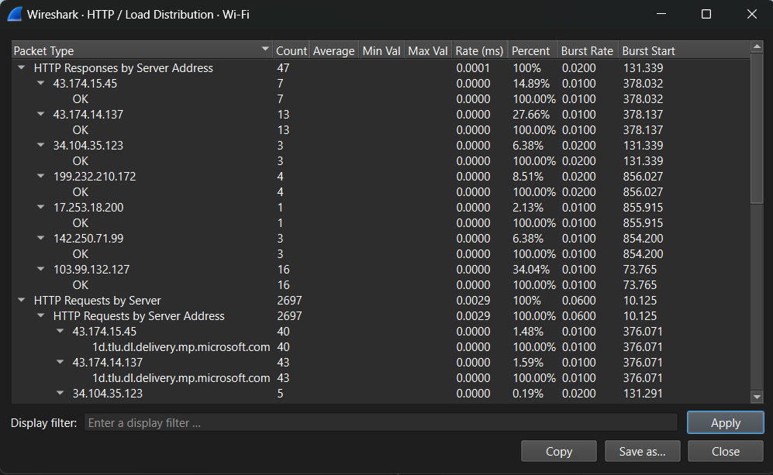

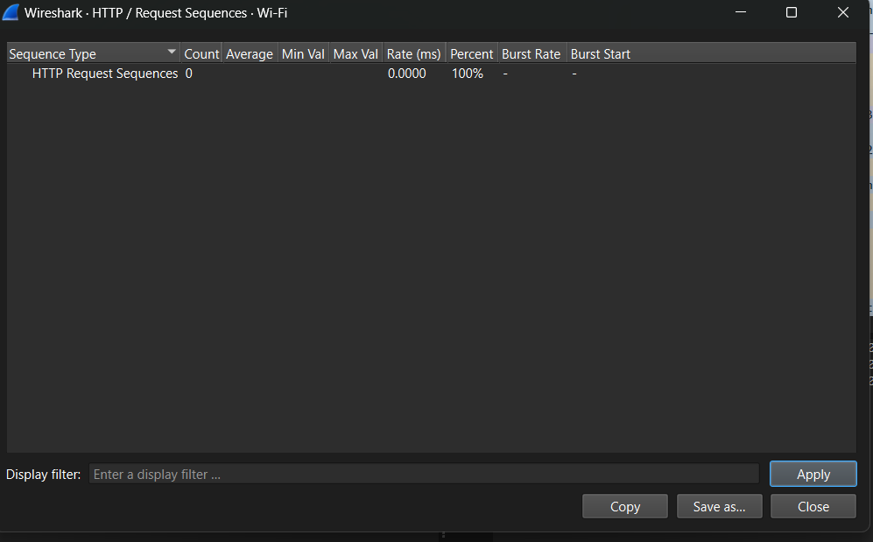

- Display all filters in wireshark. Run any three filters and explain their working.
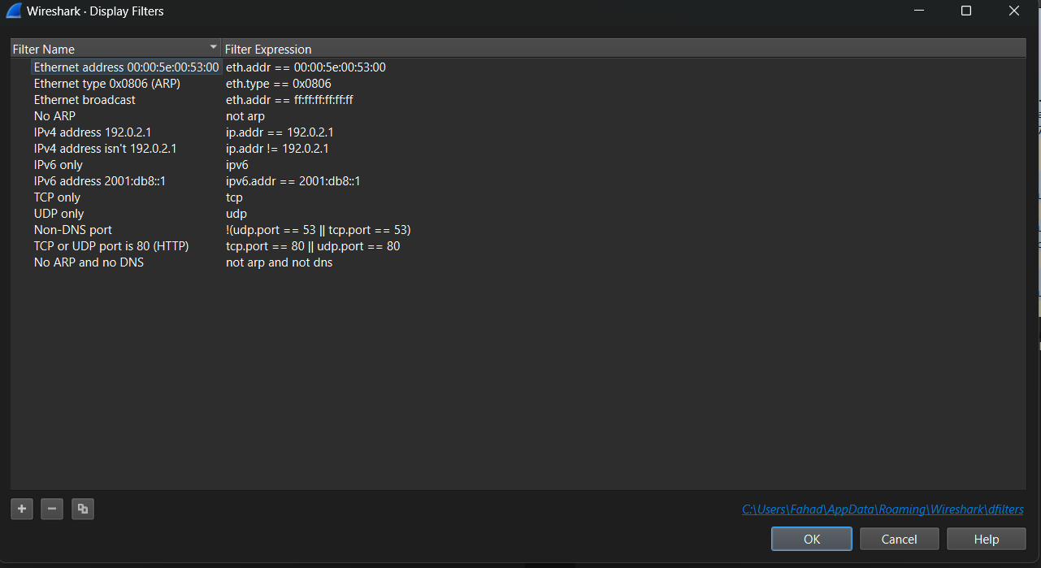

IP Filter:
Captures only the packets to or from a specific IP address. Helps you track traffic for a particular device on your network.
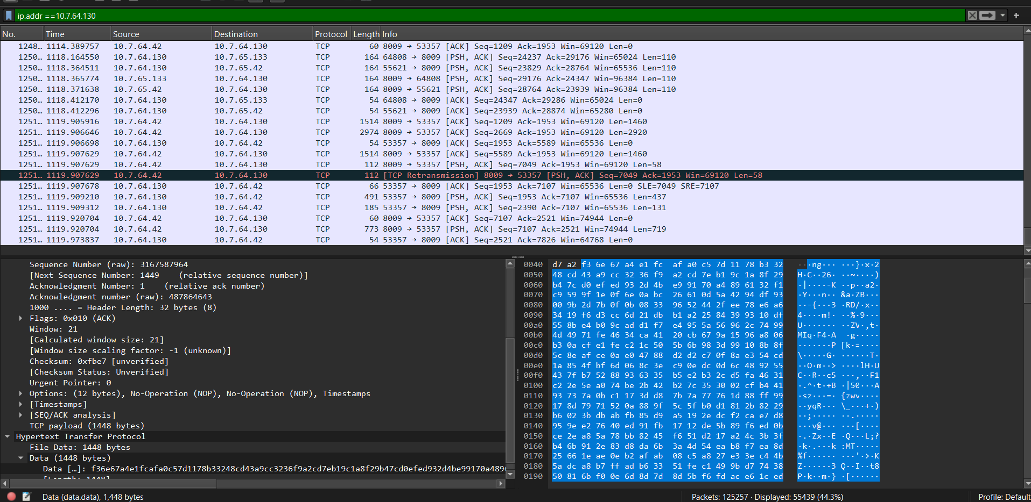

Protocol Filter:
Shows packets of a specific protocol (e.g., only HTTP or only TCP).
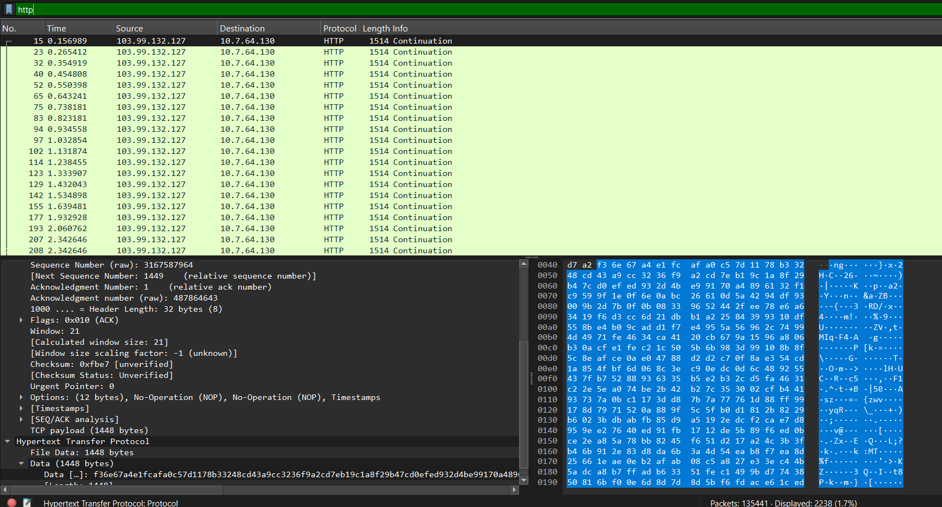

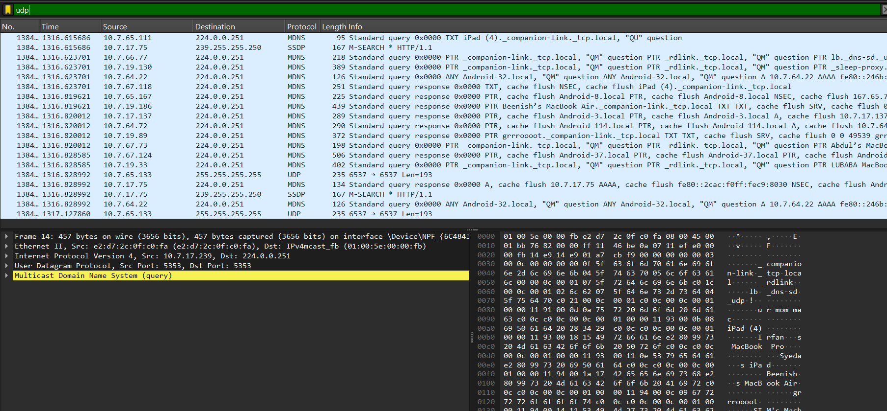

. Port Filter:
Displays only packets using a certain port. For example, port 80 for HTTP or 443 for HTTPS. Helps you zoom in on web traffic or any service running on a known port.

